Tutorial 1
PreDCR Conversion of Residential Drawing
(Basement + Parking + 5 Upper Floors and Road Widening)

How to convert Residential PreDCR drawing for preparation of submission drawing?

- How to start PreDCR?
- Double-click the PreDCR Maharashtra_Print icon on your desktop.
- The following screen will pop up for the selection CAD version.
- Please select the CAD version to run the PreDCR.

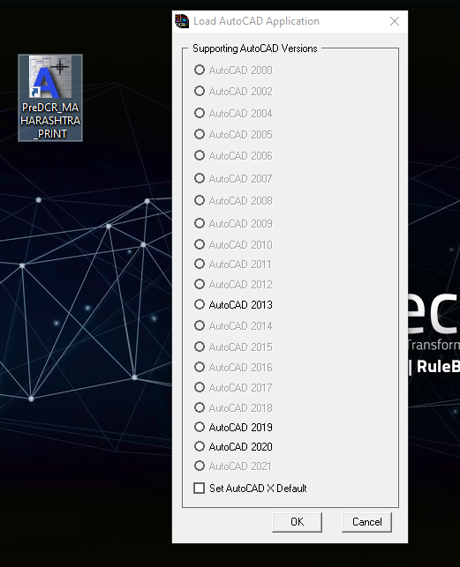

- PreDCR Toolbar and PreDCR Menu will be loaded in the CAD Application.

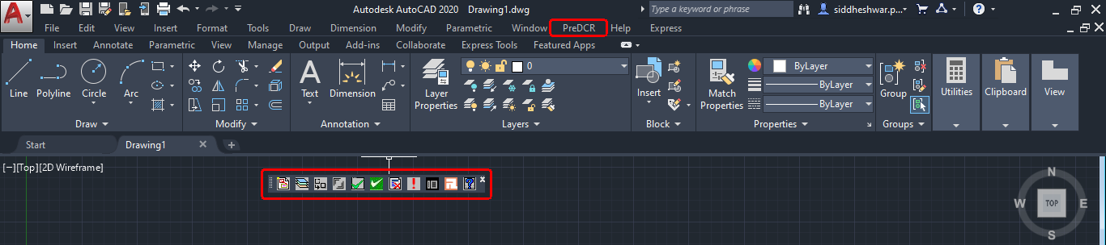

- How to create a ‘New Project’ and ‘Insert’ printing layout shet ?

- Open the drawing file form ‘Open File location’
- Click on the first tab available in the PreDCR toolbar ‘Create a new project for current drawing’.
- This command will ‘Create New project’ for the current drawing.
- ‘Project Information ‘window to select ‘Type of Project’ from the dropdown.
- Here, ‘Type of Project’ = ‘Building Development’ is selected.
- Tick on ‘For Printing do want to insert page size block’

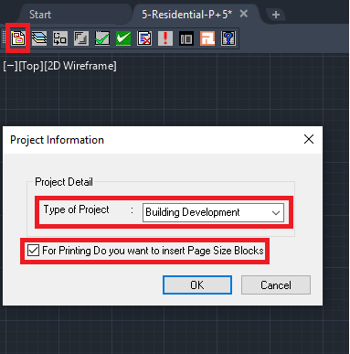

- Click ‘OK’ after selecting the type of project and insert the printing page size block.
- Select the first layout insertion size as per the drawing size.
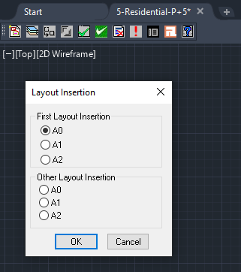
Note:
- In case more layout sheets are required,then insert the other layout as per the drawing requirement.
- Specify the layout insertion size in model space, printing layout sheet automatically inserts model space as per the selected size.

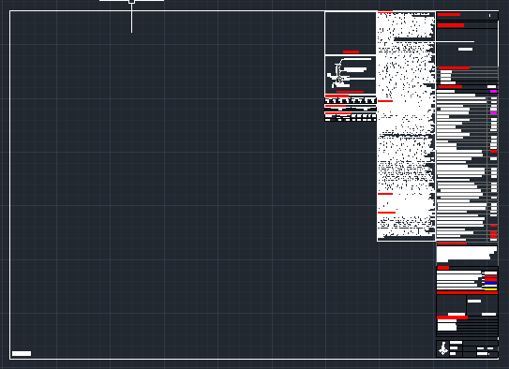

NOTE: All PreDCR conversion should be done in inserted layout sheet with closed polylines on 1:1 metric scale as follow:

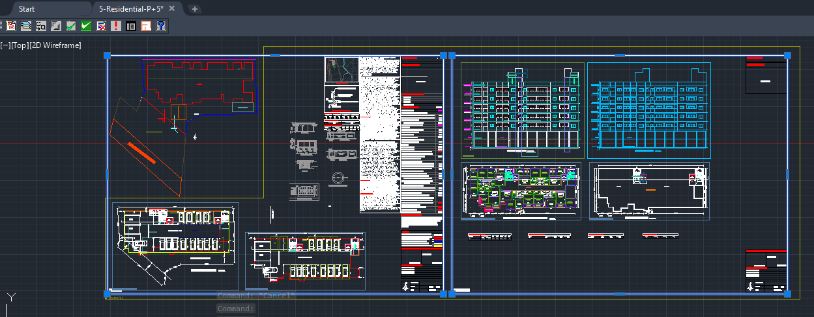

- How to Create Layers in the drawing?
- Click on the 2nd tab ‘Create DCR Layers in the current drawing’.
- This tab will create layers required for drawing conversion as per the selected ‘Type of Project’.
- Click on ‘Yes’ in the PreDCR dialog box.
- For the proposed development type software will generate the standard set of layers for drawing conversion.

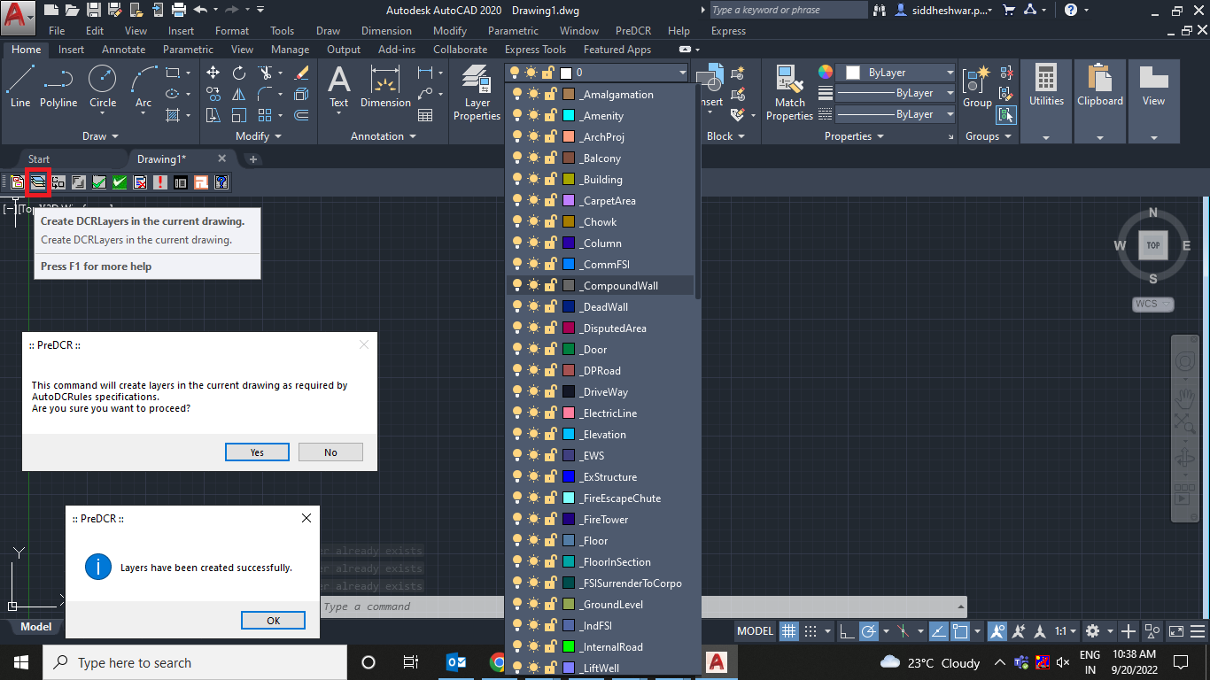

- How to convert PreDCR drawing?
Let’s learn the PreDCR drawing conversion.

This tutorial will explain the conversion process of a Residential drawing with a basement, parking floor, and 5 upper floors proposed on a plot with road widening.

  - Let’s start with the ‘Site Plan’ Conversion.

4.1.1. How to draw ‘_MainPlot’ layer?
- Go to layers drop down Select ‘_MainPlot’ layer.
- Draw plot outline in closed polyline on ‘_MainPlot’ layer.
- Give MText for ‘Plot Number/Name’.

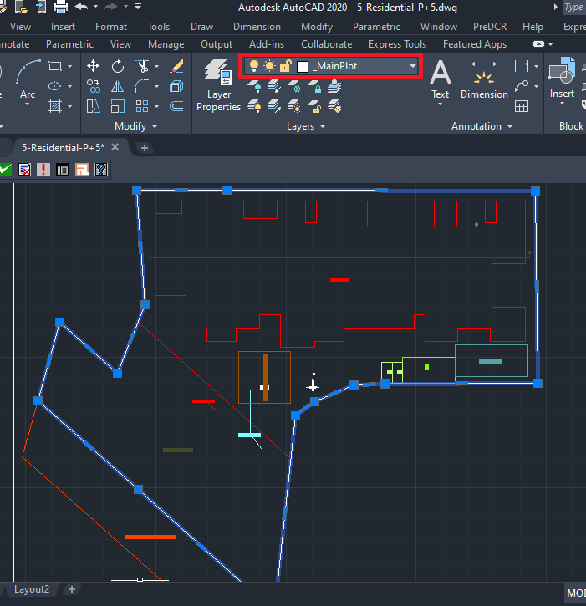

4.1.2. How to draw ‘_MainRoad’ layer?
- Go to layers drop down Select ‘_MainRoad’ layer.
- Draw main road in closed polyline on ‘_MainRoad’ layer.
- ‘_MainRaod’ layer should exactly overlap with ‘_MainPlot’ layer.
- Give MText for ‘Road name with road width’
For ex. – Here in sample drawing – ‘60.00m Wide Main Road’ is written.
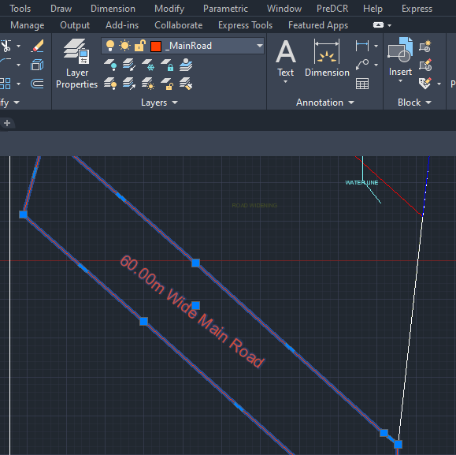

4.1.3. How to draw ‘_Road Widening’ layer?
- Go to layers drop down Select ‘_Road Widening’ layer.
- Draw road widening in closed polyline on ‘_Road Widening’ layer.
- ‘_Road Widening’ layer should be drawn inside the main plot ploy exactly overlapping the ‘_MainPlot’ and ‘_MainRoad’ layer.
- ‘_Road Widening’ layer should be marked with an available option the in PreDCR menu dropdown.
- For marking the‘_Road Widening’ layer:
Go to menu bar PreDCR MarkRoad WideningNormal (Default)/ ‘To be added in FSI’

Marking option selection should be based on the proposal.
In case road widening is considered in FSI then select ‘To be added in FSI’.
Here for the sample case ‘Normal (Default)’ option is selected for marking ‘_Road Widening’ layer.

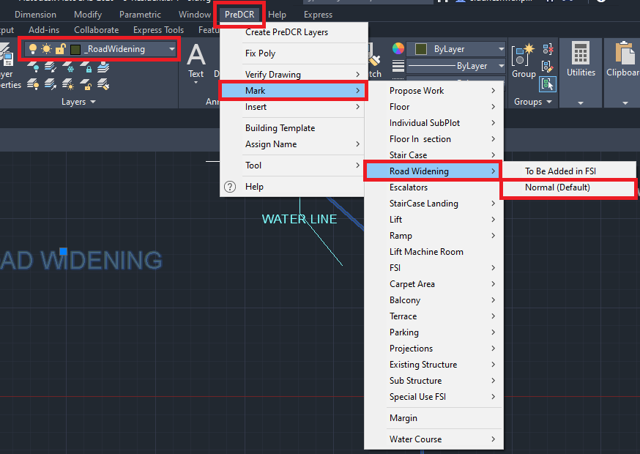

4.1.4. How to draw ‘_PWork’ lay
- Go to layers drop down Select ‘_PWork’ layer.
- Draw proposed work/building outline in closed polyline on ‘_PWork’ layer.
- ‘_PWork’ layer should be drawn inside the plot poly/site plan.
- PWork is a building profile and shall be drawn inside the plot.
- Give MText for ‘Road name with road width’

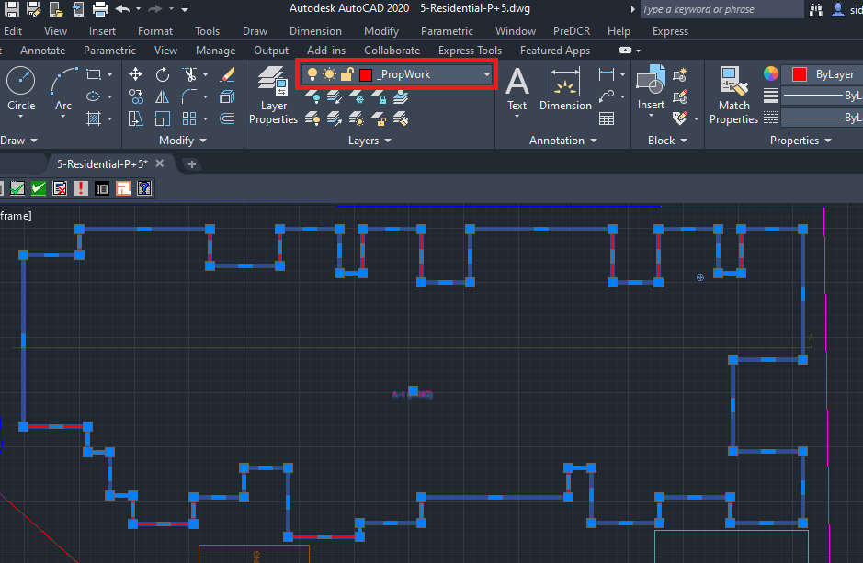

4.1.5. How to insert ‘Common reference circle’?
- Go to layers drop down Select ‘_FSI’ layer.
- For Residential proposal ‘_ResiFSI’ is selected.
- Select the ‘_ResiFSI’ layer to insert a common reference circle.
- Go to menu bar PreDCR menu drop down Select ‘Insert’ Select ‘Common reference circle.
- Common reference circle is mandatory to nsert on the same point in every floor plan and in the site plan.
For ex: Select common space available on every floor like a staircase OR lift location

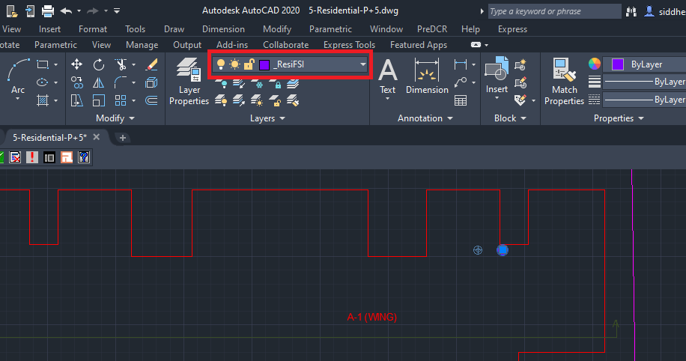

4.1.6. How to insert ‘Direction reference circle’?
- Go to layers drop down Select ‘_Floor’ layer.
- Select ‘_Floor’ layer to insert the direction reference circle.
- Go to PreDCR menu drop down Select ‘Insert’ Select ‘Direction reference circle’.
- Direction reference circle is mandatory to insert at same point in every floor plan and in sthe ite plan.
For ex: Select common space available on every floor like staircase OR lift location

Note:
Both direction and common reference circle are to be inserted together/next to each other in the same point.
Please refer to the below daring screenshot.

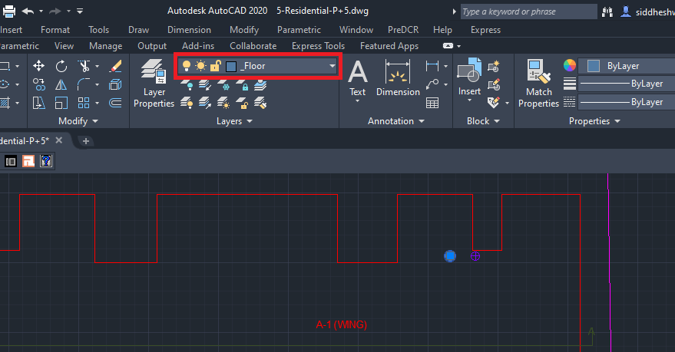

4.1.7. How to draw ‘_Sub Structure’ layer?
- Go to layers drop down Select ‘_Sub Structure’ layer.
- Draw proposed substructures on site plan in closed polyline on ‘_Sub Structure’ layer.
- ‘_Sub Structure’ layer should be drawn inside the plot poly/site.
- ‘_Sub Structure’ layer should be marked with available option in PreDCR menu dropdown.
- For marking ‘_Sub Structure’
Go to PreDCR MarkSub StructureRain Water Harvesting
Here, as per the sample case Rain Water Harvesting is selected.

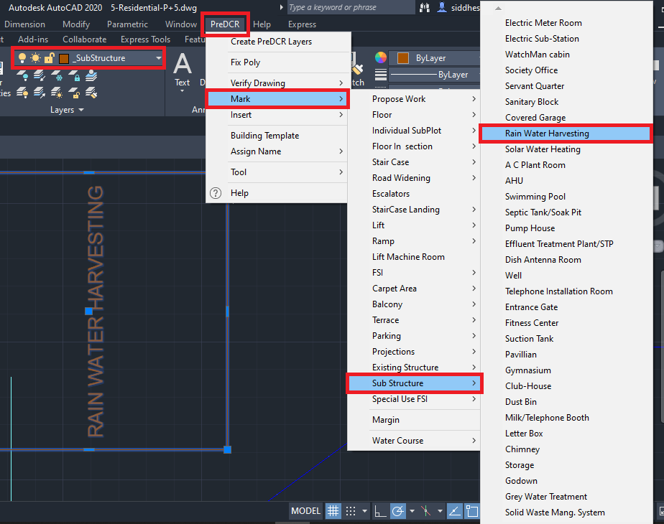

Note:
All types of substructures marking options available in the dropdown, please select as per the proposal.

4.1.8. How to draw ‘_Sewageline’ layer?
- Go to layers drop down Select ‘_Sewageline’ layer.
- Draw proposed sewage line in closed polyline on ‘_Sewageline’ layer.
- ‘_Sewageline’ layer should be drawn in the plot poly/site plan.
- Give MText as ‘Sewage Line’.
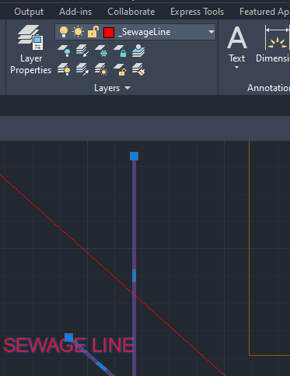

4.1.9. How to draw ‘_Waterline’ layer?
- Go to layers drop down Select ‘_Waterline’ layer.
- Draw proposed water line in closed polyline on ‘_Waterline’ layer.
- ‘_Waterline’ layer should be drawn in the plot poly/site plan.
- Give Mtext as ‘Waterline’.

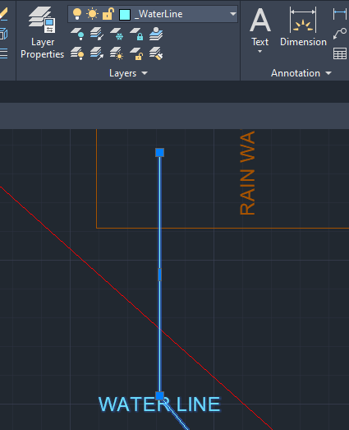

4.1.10. How to draw ‘_Tank’ layer?
- Go to layers drop down Select ‘_Tank’ layer.
- Draw proposed tank in closed polyline on ‘_Tank’ layer.
- ‘_Tank’ layer should be drawn in the main plot poly/site plan.
- ‘_Tank’ layer should be assigned name with available option in PreDCR menu.
- For Assign Name to ‘_Tank’ layer
Go to PreDCR Assign NameTank.
- In Tank name information dialog box:
Fill up the tank information as per proposal.
For ex: ‘Tank position’= Underground, ‘Tank name/no’=UGWT-1
- Similarly assign name for ‘Overhead Tank’ as follow:
Go to PreDCR Assign NameTank.
- In Tank name information dialog box:
Fill up the tank information as per proposal.
For ex: ‘Tank position’= Overhead, ‘Tank name/no’=OHWT-1

UGWT-1 on Plot Level
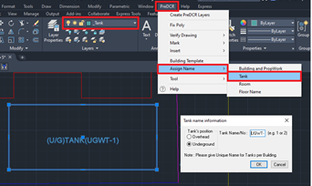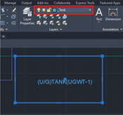

OHWT-1 in Section Block

Note:
After adding tank information, select both tank polyline drafted in the site plan and section for assigning

4.1.11. How to insert North Direction?
- Go to layers drop down Select ‘_Location Plan’ layer.
- To insert North Direction:
Go to the PreDCR menu Select ‘Insert’ Select ‘North Direction’ Specify Insertion Point in the drawing.

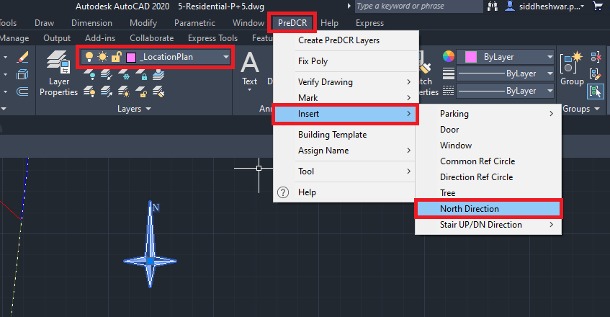

  - Let’s start the ‘Basement Floor Plan’ Conversion.

4.2.1. How to draw the basement floor outline on the ‘_Parking’ layer?
- Go to layers drop down Select ‘_Parking’ layer.
- Draw proposed basement outline in closed polyline on ‘_Parking’ layer.
- Give MText as ‘Basement Parking’ OR ‘Parking’ as proposed.

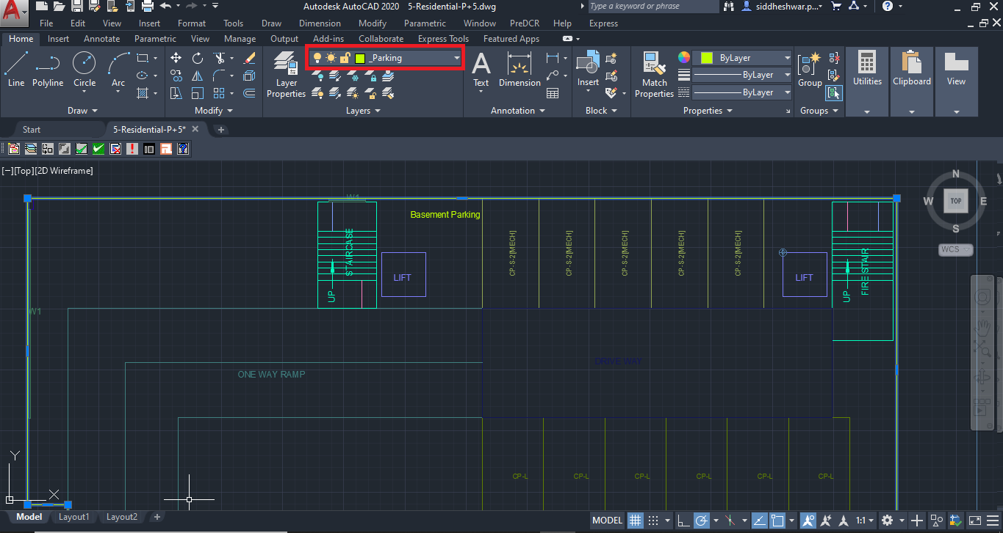

4.2.2. How to insert the individual car parking inside the basement floor?
- To insert the individual car parking :
Go to the PreDCR menu Select ‘Insert’ Select ‘Parking’ Select ‘Car’ Select ‘Small Car’ Select Floor/ Main Plot poly Specify insertion pointSpecify number for individual parking. Insert car parking as per the proposal.
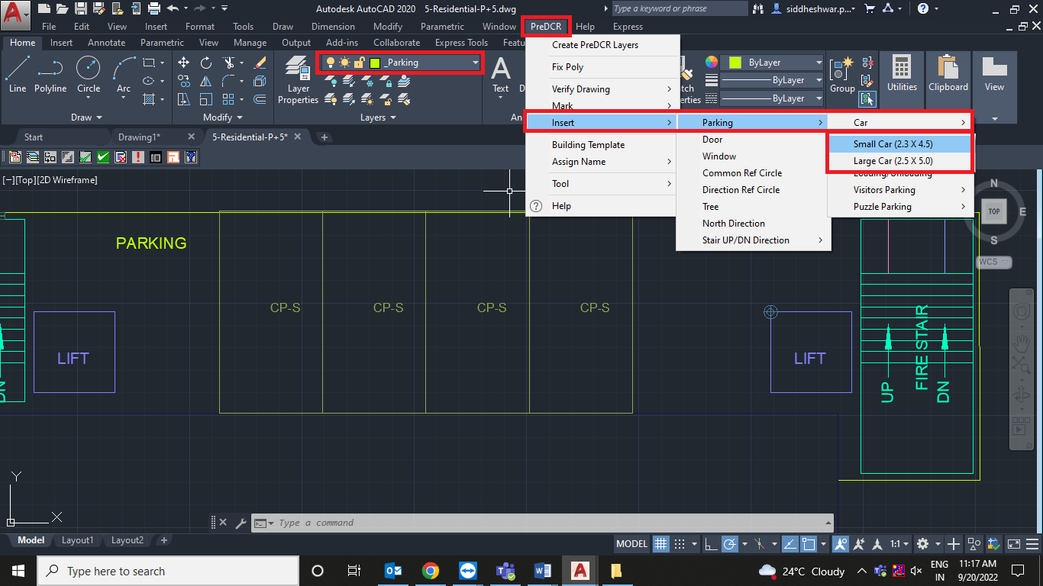
- For marking individual parking:
Go to the PreDCR menu Select ‘Mark’ Select ‘Parking’ Select ‘Two Stacked’ Select individual parking poly.
Marking options should be selected as per the proposal.

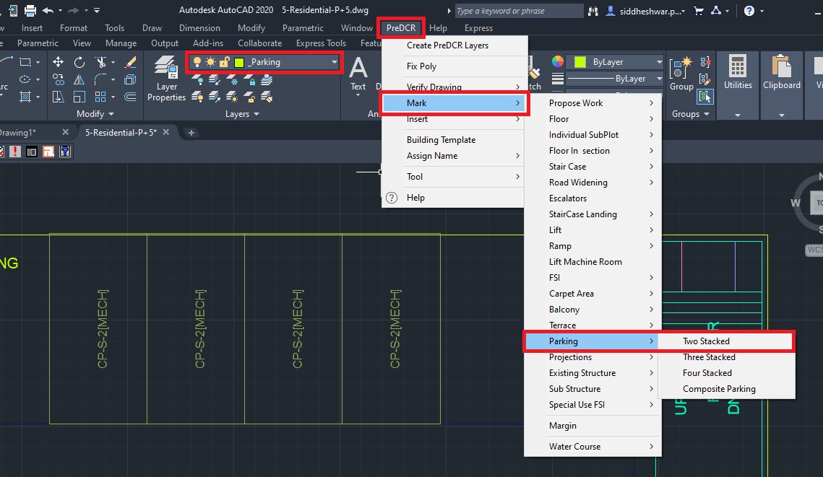

4.2.3. How to draw ‘_Ramp’ layer?
- Go to layers drop down Select ‘_Ramp’ layer.
- Draw proposed ramp outline in closed polyline on ‘_Ramp’ layer.
- ‘_Ramp’ layer should be inside basement parking poly line.
- ‘_Ramp’ layer shall be drawn with center line type polyline, from center to center.
- For marking of ‘_Ramp’ layer:
Go to PreDCR menu Select ‘Mark’ Select ‘Ramp’ Select ‘Two-way ramp’.
Options available in software to mark the ramp:
Ramp Ramp for Handicapped
Ramp Unmark (Default)
Ramp One-way ramp
Ramp Two-way ramp
Select marking options as per requirement.

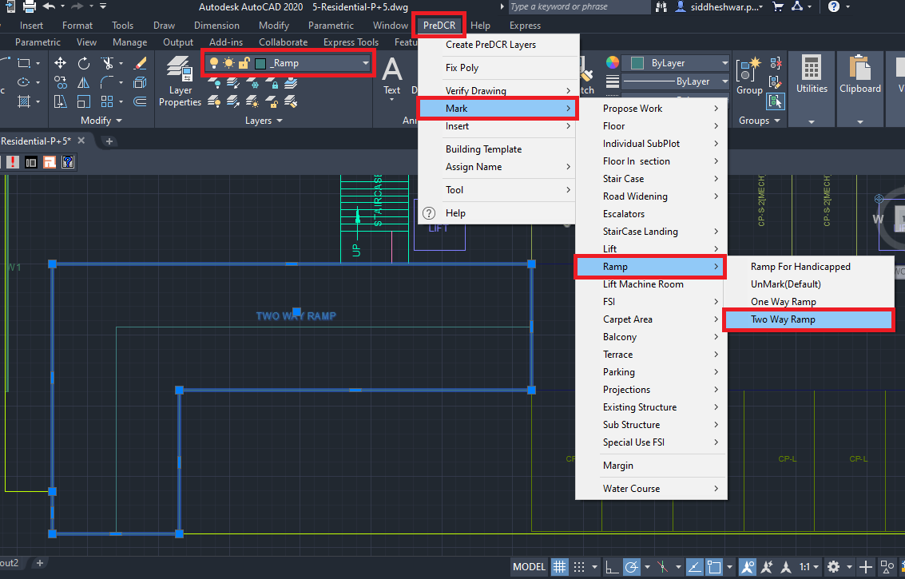

4.2.4. How to draw ‘_LiftWell’ layer?
- Go to layers drop down Select ‘_LiftWell’ layer.
- Draw lift well on innerside in closed polyline on ‘_LiftWell’ layer.
- For marking of ‘_LiftWell’ layer:
Go to PreDCR menu Select ‘Mark’ Select ‘Lift’ Select ‘Lift Default’.
Options available to mark the lift:
LiftLift Default.
LiftCar lift
LiftMRL
LiftHydraulic lift
LiftFire lift
LiftFireman lift
Select marking options as per requirement.

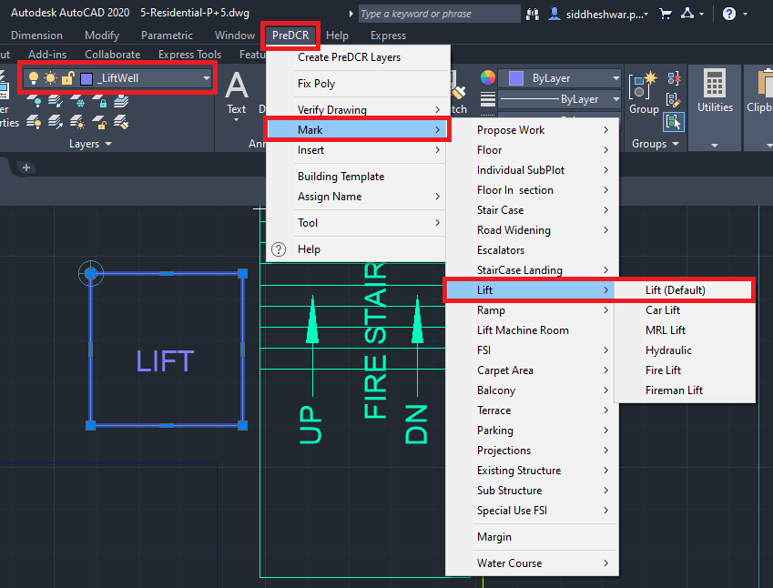

4.2.5. How to draw ‘_Staircase’ layer?
- Go to layers drop down Select ‘_Staircase’ layer.
- Draw staircase block on inner side in closed polyline on ‘_Staircase’ layer.
- ‘_Staircase’ poly should contain Intermediate Landing, Floor Landing & Each Tread as an open polyline.
- For marking of ‘_Staircase’ layer:
Go to PreDCR menu Select ‘Mark’ Select StaircaseStaircase (Default
Options available to mark the Staircase:
StaircaseNo of flight 3 Flight OR 4 Flight
StaircaseStaircase (Default)
StaircaseOpen Staircase
StaircaseFire escape staircase
StaircaseFab/Spiral stair
Select marking options as per requirement.
- For marking of staircase intermediate landing, flight width and floor landing:
- Go to PreDCR menu Select ‘Mark’ Select ‘Staircase Landing’ Select ‘Intermediate landing’.
- Go to PreDCR menu Select ‘Mark’ Select ‘Staircase Landing’ Select ‘Flight Width’.
- Go to PreDCR menu Select ‘Mark’ Select ‘Staircase Landing’ Select ‘Floor Landing’.

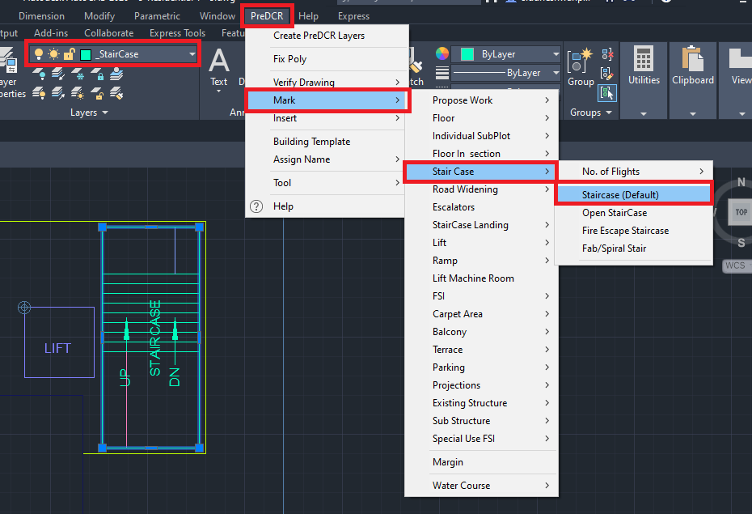

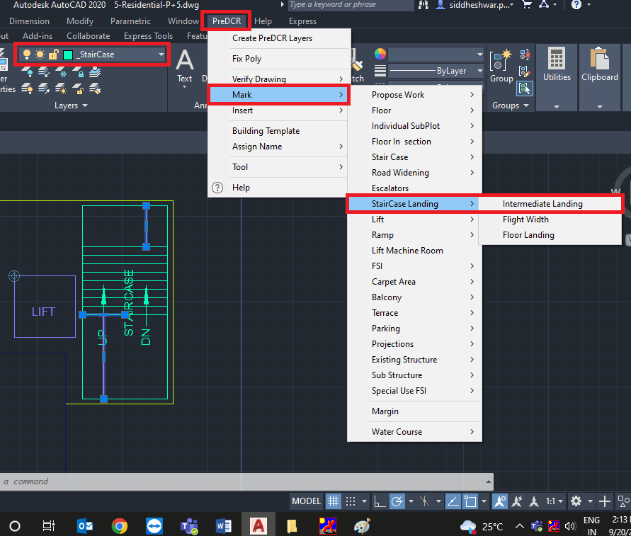
- To insert stair Up/DN direction:
Go to PreDCR menu Select ‘Mark’ Select ‘Stair Up/DN’ Select ‘UP/DN’.

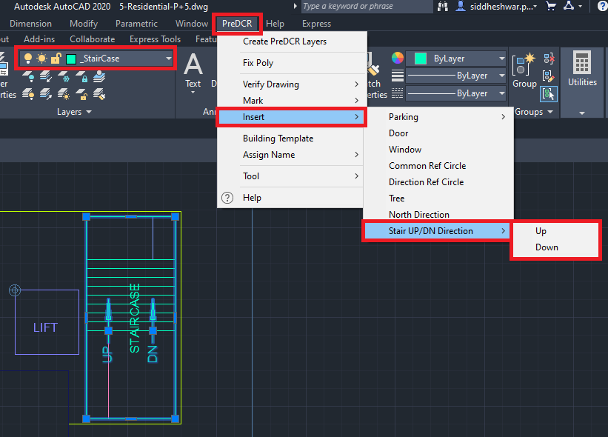

4.2.6. How to draw a basement floor plan on ‘_Floor’ layer?
- Go to layers drop down Select ‘_Floor’ layer.
- Draw basement floor plan outline in closed polyline on ‘_Floor’ layer.
- ‘_Floor’ layer poly should be drawn around the converted basement floor plan (in parking poly).

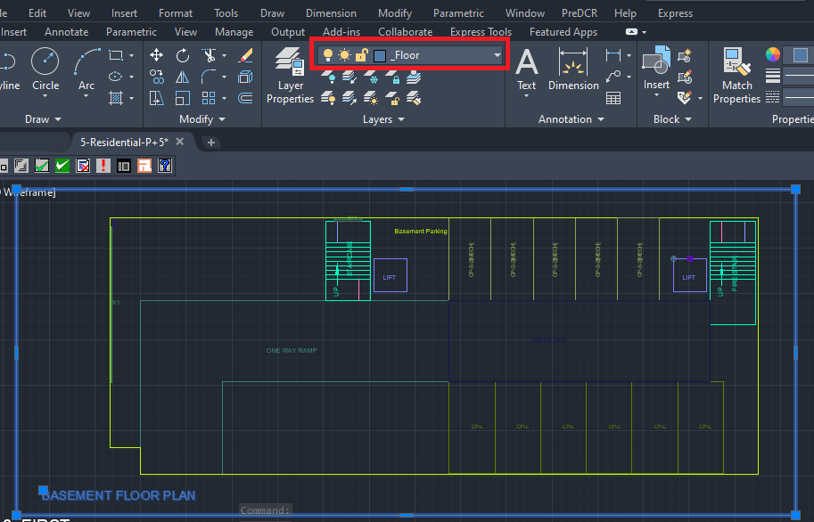

NOTE:
‘Common Reference Circle’ and ‘Direction Reference Circle’ should be inserted in the basement floor plan the on ‘_FSI’ layer and ‘_Floor’ layer respectively in the same location as of other floor plans.
Please refer 4.1.5 and 4.1.5 sections.

  - Let’s start Parking/Stilt Plan Conversion.

4.3.1. How to draw Parking/Stilt Plan on ‘_Parking’ layer?
- Go to layers drop down Select ‘_Parking’ layer.
- Draw parking floor plan outline in closed polyline on ‘_Parking’ layer.
- Give MText as ‘Parking’/’Stilt Parking’.
- For car insertion:
Go to PreDCR menu Select ‘Insert’ Select ‘Parking’ Select ‘Car’ Select ‘Small Car’ Select Floor/ Main Plot poly Specify insertion pointSpecify number for individual parking. Insert car parking as per proposal.
- For car marking:
- For marking individual parking:
Go to PreDCR menu Select ‘Mark’ Select ‘Parking’ Select ‘Two Stacked’ Select individual parking poly.
Marking options should be selected as per the proposal.
Refer individual car insertion section 4.2.2.

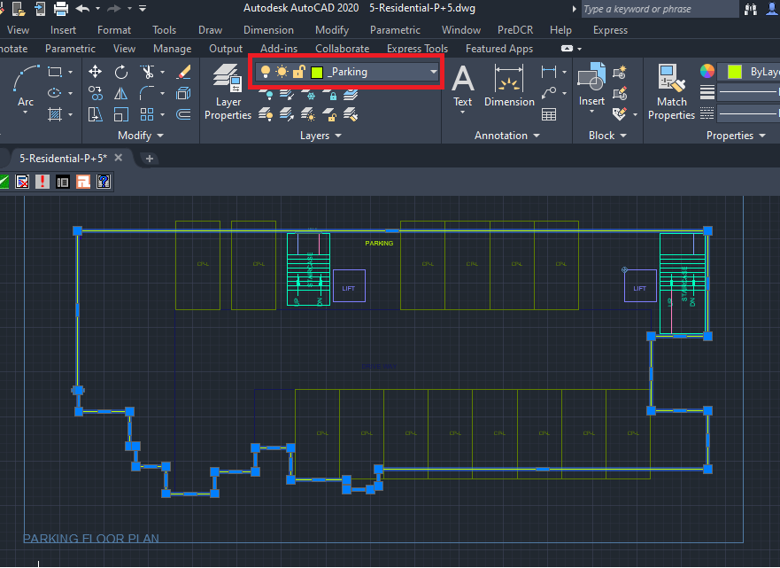

NOTE: Complete the floor plan by converting the staircase block, and lift well as explained in the 4.2.4 and 4.2.5 sections.

  - Let’s start the First Floor/Upper Floor Plan Conversion.

4.4.1. How to draw a Residential habitable floor plan on the ‘_ResiFSI’ layer?
- Go to layers drop down Select ‘_ResiFSI’ layer.
- Draw a habitable floor plan outline in a closed polyline on the ‘_ResiFSI’ layer.
- For marking of ‘_ResiFSI’ layer:
Go to the PreDCR menu Select ‘Mark’ Select ‘FSI’ Select ‘Normal (Default)’.
For the existing floor in case of addition/alteration case
Go to the PreDCR menu Select ‘Mark’ Select ‘FSI’ Select ‘Existing FSI’.

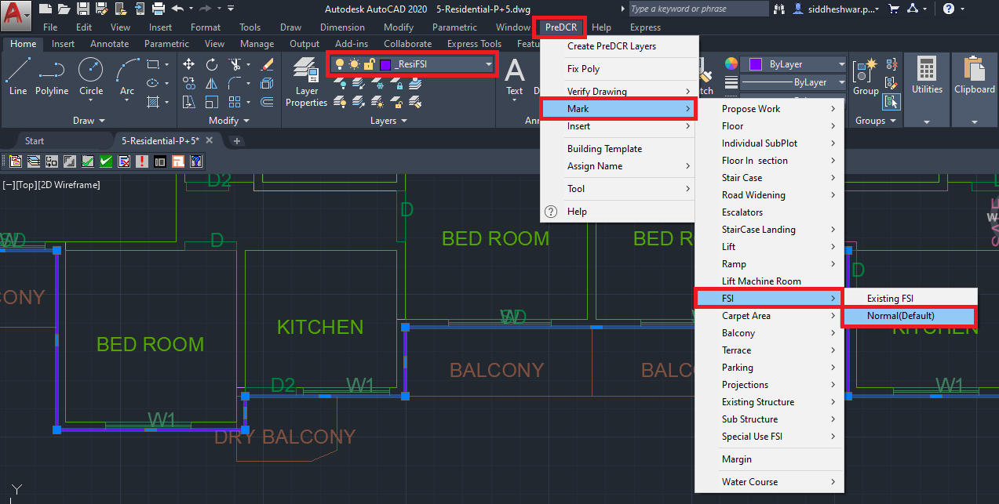

NOTE:
‘Common Reference Circle’ and ‘Direction Reference Circle’ should be inserted in the basement floor plan on the ‘_FSI’ layer and ‘_Floor’ layer respectively in the same location as of other floor plans.
Please refer 4.1.5 and 4.1.5 sections.

4.4.2. How to draw ‘_Room’ layer?
- Go to layers drop down Select ‘_Room’ layer.
- Draw every room in closed polyline on ‘_Room’ layer.
- To assign ‘Room’ name ‘_Room’ layer:
Go to the PreDCR menu Select ‘Assign Name’ Select ‘Room’ use name From the list of room names For ex: Select ‘Bed Room’/’Toilet.
As per the proposed plan.
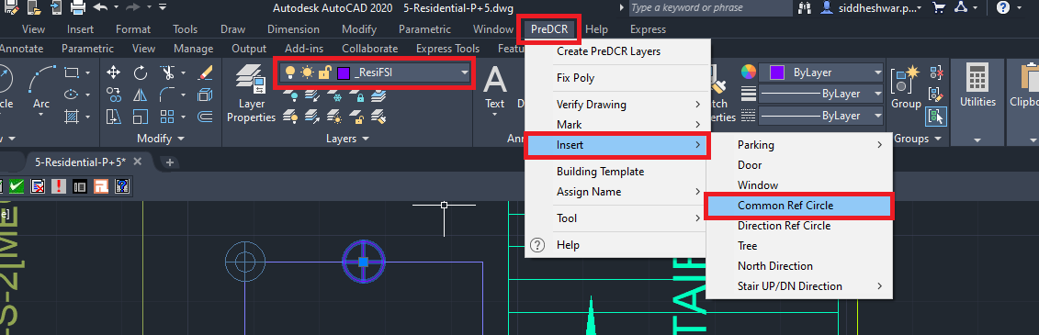

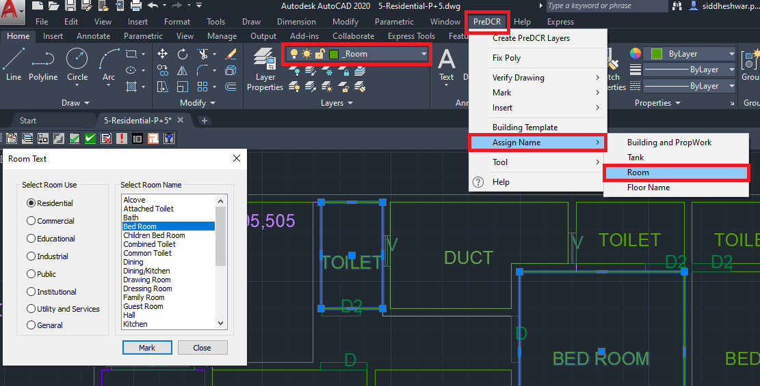

4.4.3. How to draw the ‘_CarpetArea’ layer?
- Go to layers drop down Select ‘_CarpetArea’ layer.
- Draw carpet outline in closed polyline on ‘_CarpetArea’ layer.
- ‘_CarpetArea’ layer represents the carpet area of the tenement/dwelling unit area.
- For marking the‘_CarpetArea’ layer:
Go to the PreDCR menu Select ‘Mark’ Select ‘Carpet Area’ Select ‘Normal (Default)’.
To give tenement numbers OR name (Ex. A-101,201,301…) edit carpet text.
Options available to mark the Carpet Area:
Go to menu bar PreDCR MarkCarpet Area Splited Tenement
Go to menu bar PreDCR MarkCarpet Area Slum development Rehab OR Sale
Go to menu bar PreDCR MarkCarpet Area Normal (Default).

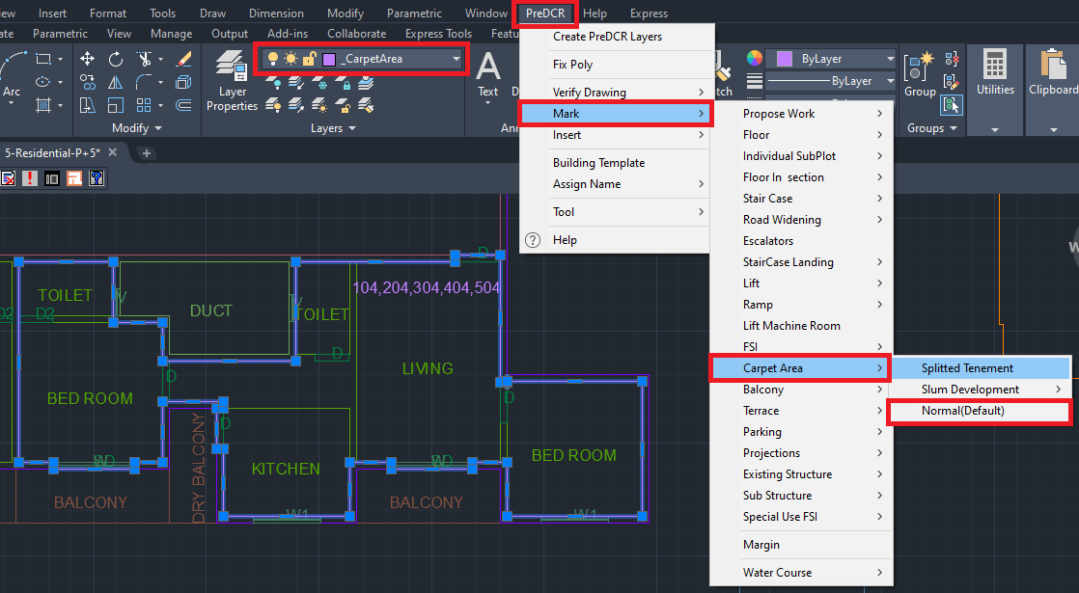

4.4.4. How to insert the door on ‘Door’ layer?
- Go to layers drop down Select ‘Door’ layer.
- To insert doors on the ‘Door’ layer:
Go to the PreDCR menu Select ‘Insert’ Door.
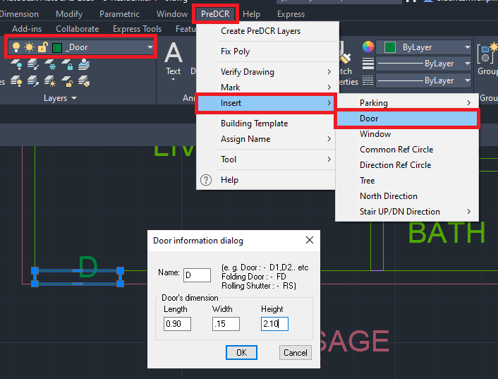

- In the ‘Door Information Dialog’ box fill up the information:
For ex: ‘Width’=0.90m, ‘Depth’=0.15m, ‘Height’ =2.10m and ‘Name’ = D as shown.
Insert the door as per the requirement
Similarly, insert ‘Rolling Shutter’ and fill up information in the dialog box as per the proposal:
For ex: ‘Width’=2.70m, ‘Depth’=0.15m, ‘Height’ =2.10m and ‘Name’ = R/S.
For rolling shutter in ‘Name’ = ‘R/S’ is fill up instead of ‘D’.

4.4.5. How to insert a window on the ‘_Window’ layer?
- Go to layers drop down Select ‘_Window’ layer.
- To insert doors on the ‘_Window’ layer:
Go to the PreDCR menu Select ‘Insert’ Select ‘Window’.
Fill up window information in a dialog box:
For ex: ‘Width’ = 1.50m, ‘Depth’=0.15m, ‘Height’=1.20m and ‘Name’ =W1.
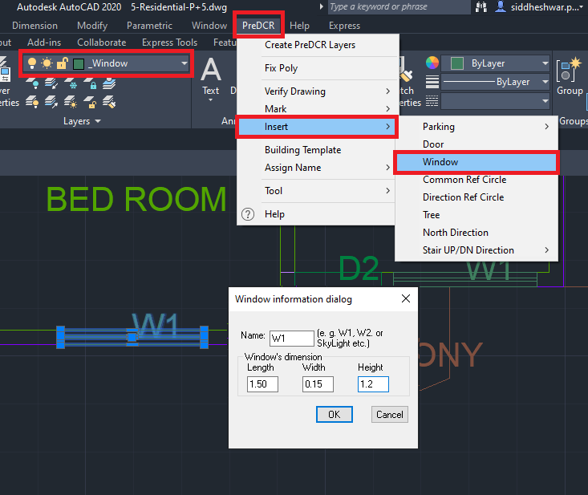
Similarly insert ‘Ventilator’ and fill up the information as per requirement.
For ex: ‘Width’ = 0.6 m, ‘Depth’=0.23m, ‘Height’=1.2 m and ‘Name’ = V as shown.
For ventilator in ‘Name’ = ‘V’ is fill up instead of ‘W’.

4.4.6. How to draw ‘_Ventilation Shaft’ layer?
- Go to layers drop down Select ‘_Ventilation Shaft’ layer.
- Draw ventilation shaft outline in closed polyline on ‘_Ventilation Shaft’ layer.
- Give the MText as ‘Ventilation Shaft’.

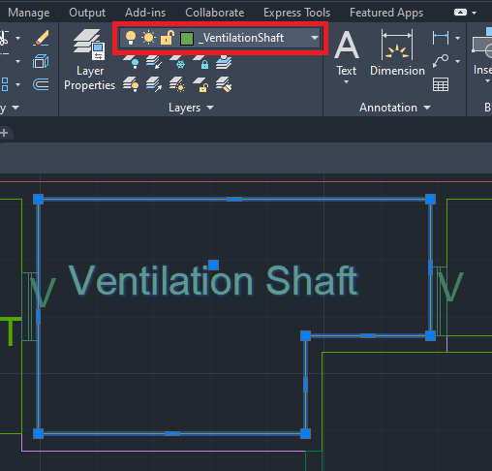
4.4.7. How to draw the ‘_Balcony’ layer?
- Go to layers drop down Select ‘_Balcony’ layer.
- Draw balcony outline in closed polyline on ‘_Balcony’ layer.
- ‘_Balcony’ layer should be drawn outside the FSI poly exactly overlapping with FSI poly.
- For marking of ‘_Balcony’ layer:
Go to PreDCR menu MarkBalcony Unmark (Default)/ Enclosed Balcony.
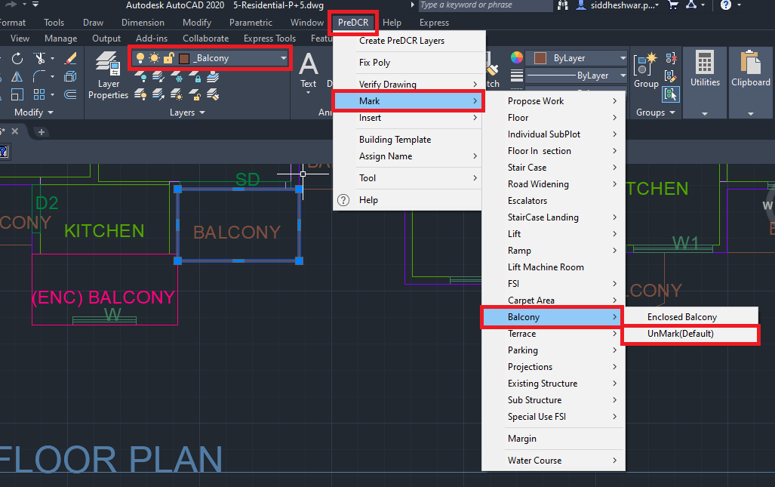
4.4.8. How to draw a habitable floor on ‘_Floor’ layer?
- Go to layers drop down Select ‘_Floor’ layer.
- Draw floor plan outline in closed polyline on ‘_Floor’ layer.
- ‘_Floor’ layer poly should be drawn outside/all around the converted floor plan.
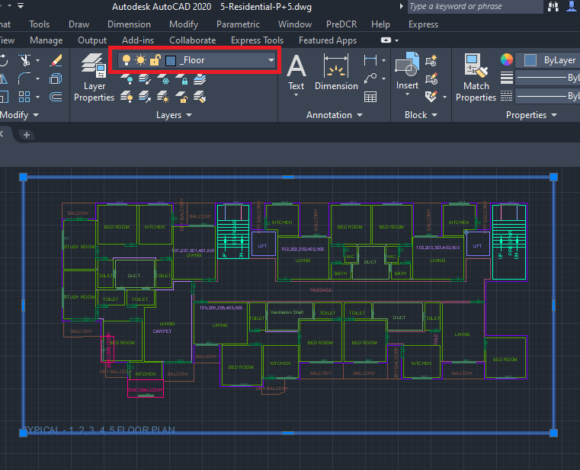
NOTE:
‘Common Reference Circle’ and ‘Direction Reference Circle’ should be inserted in the all the floor plan the on ‘_FSI’ layer and ‘_Floor’ layer respectively in the same location as of other floor plans.
Please refer 4.1.5 and 4.1.5 sections.
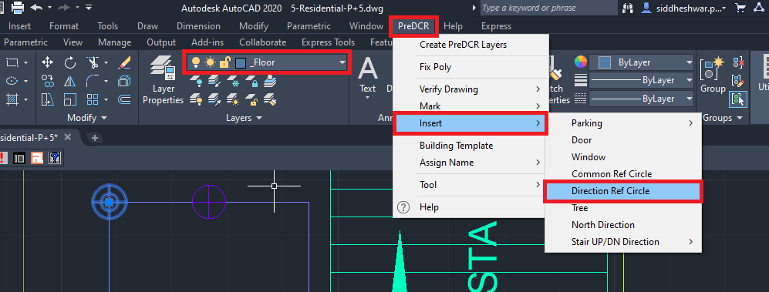
NOTE: Complete the floor plan by converting the staircase block, and lift well as explained in the 4.2.4 and 4.2.5 sections.
Similarly, convert the remaining habitable floor plans.

4.4.9. How to draw a terrace floor on the ‘_Terrace’ layer
- Go to layers drop down Select ‘_Terrace’ layer.
- Draw terrace floor plan outline in closed polyline on the ‘_Terrace’ layer.
- For marking of ‘_Terrace’ layer:
Go to the PreDCR menu Select ‘Mark’ Select ‘Terrace’Common Terrace/ Individual
Terrace.

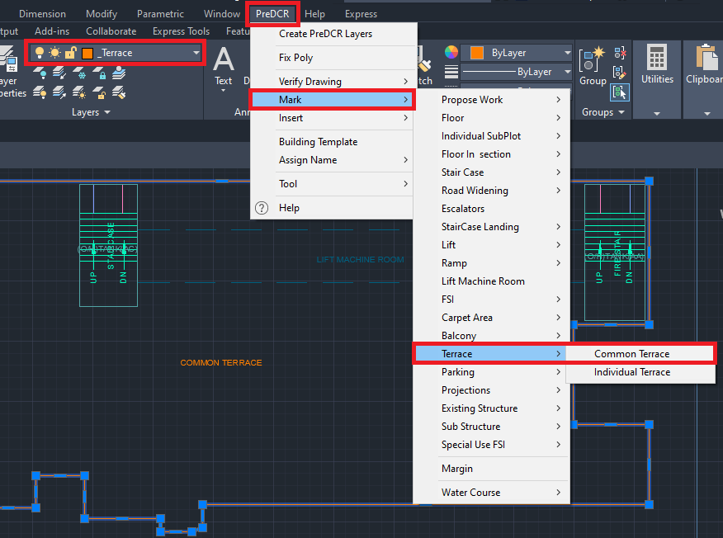

4.4.10. How to draw Over Head Water Tank (OHWT) on the terrace floor on the ‘_Tank’ layer?
- Go to layers drop down Select ‘_Tank’ layer.
- Draw OHWT on the terrace floor plan in closed polyline on the ‘_Tank’ layer.
- To Assign Name to ‘_Tank’ layer:
Go to PreDCR menu Select ‘Assign Name’ Select ‘Tank’
Fill up the Tank name information dialog box:
For ex: ‘Tank position’= Overhead, ‘Tank name/no’=OHWT-1
Similarly, assign name for ‘Unground Tank Water Tank ‘:
Go to PreDCR menu Select ‘Assign Name’ Select ‘Tank’
Fill up the Tank name information dialog box:
For ex: ‘Tank position’= Underground, ‘Tank name/no’=UGWT-1

OHWT-1 in Terrace Floor Plan OHWT-1 in Section
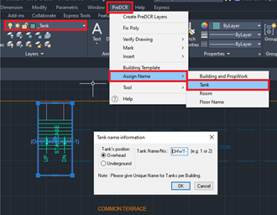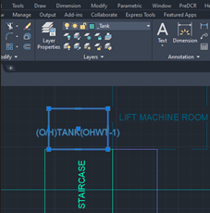
Note: After adding tank information in the dialog box, to assign a name select both ‘_Tank’ polyline drafted in the ‘Floor Plan’ and in ‘Floor Section’ for assigning.

4.4.11. How to draw lift machine room ‘_LiftWell’ layer?
- Go to layers drop down Select ‘_LiftWell’ layer.
- Draw lift machine room in closed polyline on ‘_LiftWell’ layer.
- For marking of ‘_LiftWell’ layer:
Go to PreDCR menu Select ‘Mark’ Select ‘Lift Machine Room’ Select both lifts well poly
drafted in ‘Floor Section’ and ‘Terrace Floor Plan’.

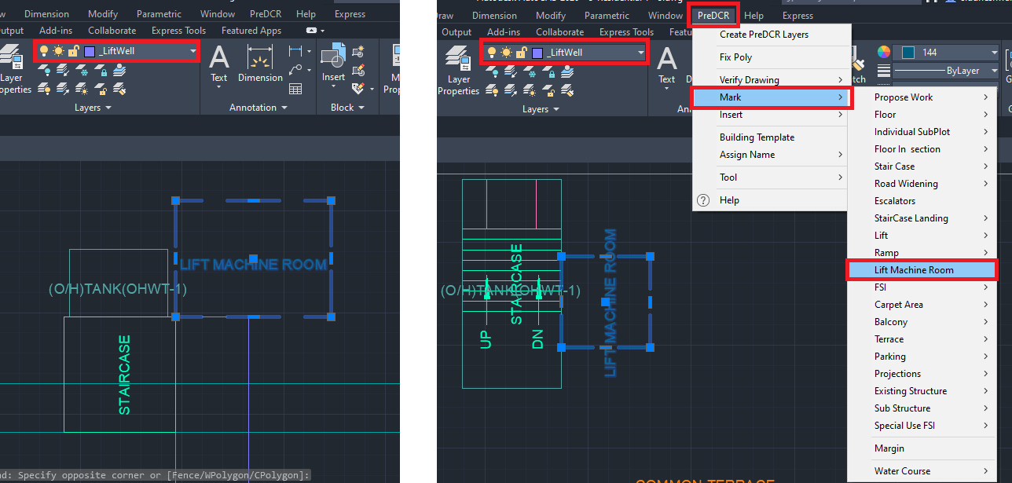
Lift machine room in Section Lift machine room in Terrace Floor Plan
NOTE: Complete the floor plan by converting the staircase block.
Please refer 4.2.4 section for staircase block conversion.

  - Let’s start the Floor Section Conversion.

4.5.1. How to draw floor section on ‘_FloorInSection’ layer?
- Go to layers drop down Select ‘_FloorInSection’ layer.
- Draw each and every floor in closed polyline on ‘_FloorInSection’ layer separately.

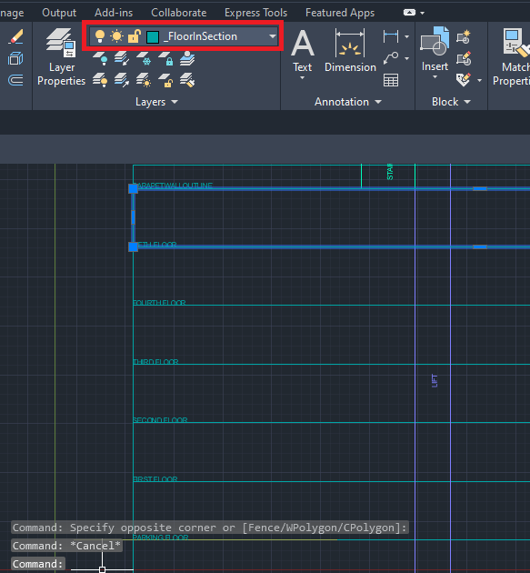

4.5.2. How to link floor section and floor plans?
- To link the floor in section to floor in the plan.
Go to PreDCR Menu Select ‘Assign Name’ Select Floor Name/Nos.
Fill in the information in the ‘Auto Assign floor name’ dialog’ box:
‘Select floor name’ from a drop-down (for ex: Basement)
Select ‘OK’, then select the corresponding floor poly and floor in section poly in the drawing Basement floor is selected in plan and section.
Only ‘Plinth’ need to Mtext in the section.
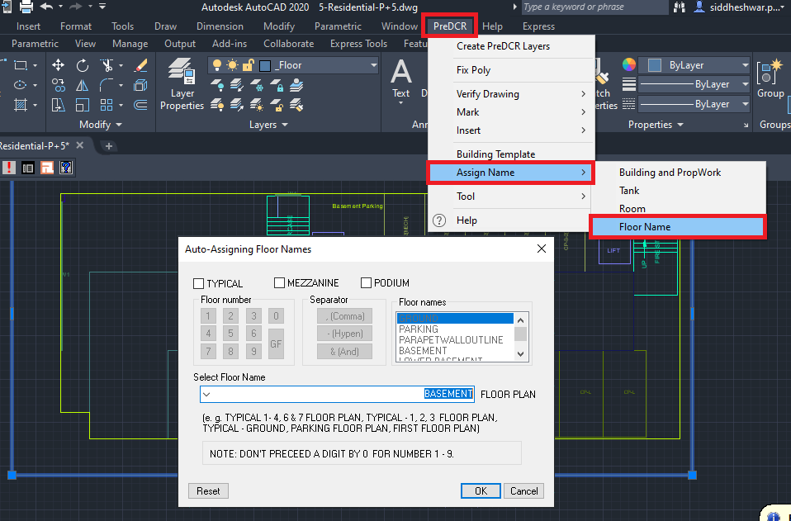

- To continue floor name assign select ‘Yes’ and follow the process as follows:
Fill in the information in the ‘Auto Assign floor name’ dialog’ box:
‘Select floor name’ from drop-down (for ex: Parking Floor Plan)
Select ‘OK’, then select the corresponding floor poly and floor in section poly in the drawing Ground floor is selected in plan and section.

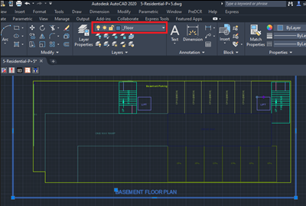
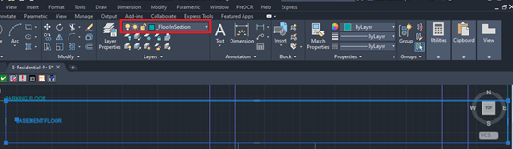
- To assign name to typical floor , select ‘Yes’ and follow the process as follows:
Fill in the information in ‘Auto Assign floor name’ dialog’ box:
Select the check box of ‘Typical’
Select floor no.
Select separator
Select other floor no.
Select ‘OK’
Select floor poly in section (First and Second floor) and corresponding floor plan.

- To assign terrace floor name, select ‘Yes’ and follow the process as follows:
Fill in the information in the ‘Auto Assign floor name’ dialog’ box:
‘Select floor name’ from a drop-down (for ex: Terrace floor)
Select ‘OK’, then select the corresponding floor poly and floor in section poly in the drawing Ground floor is selected in plan and section.
The floor Plan will be automatically linked with the Section Floor by matching the Floor Name.

4.5.3. How to draw staircase headroom in the ‘_Staircase’ layer?
- Go to layers drop down Select ‘_Staircase’ layer.
- Draw staircase headroom in closed polyline on the ‘_Staircase’ layer.
- Give the MText as ‘Staircase OR Staircase Head Room’.
Refer to 4.4.11 section to draw lift machine room in closed polyline on ‘_LiftWell’ layer.
Refer to 4.4.10 section to draw Tank in closed polyline on ‘_Tank’ layer.

4.5.4. How to draw ground level in ‘_GroundLevel’ layer in Floor Section?
- Go to layers drop down Select ‘_GroundLevel’ layer.
- Draw the Ground level line as per polyline on ‘_GroundLevel’ layer.
- Give ‘MText’ as ‘Ground Level ‘.

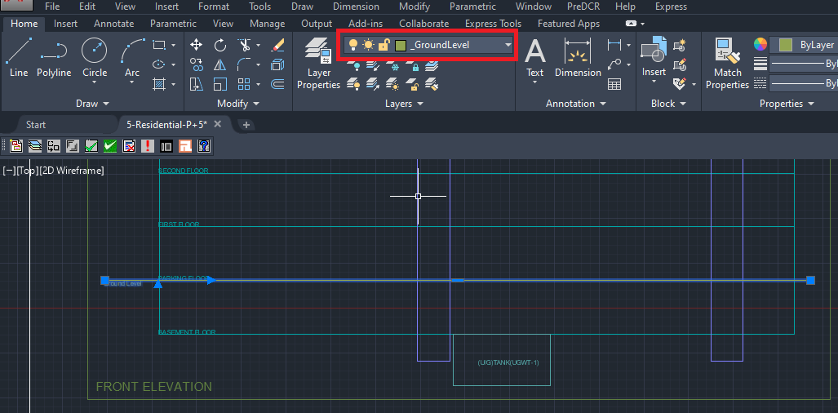

4.5.5. How to draw section details ‘_Section’ layer ?

- Go to layers drop down Select ‘_Section’ layer.
- Draw ‘_Section’ layer poly to group all floor in section, lift machine room, staircase head room and tank details.
- Give ‘MText’ as ‘Section‘.

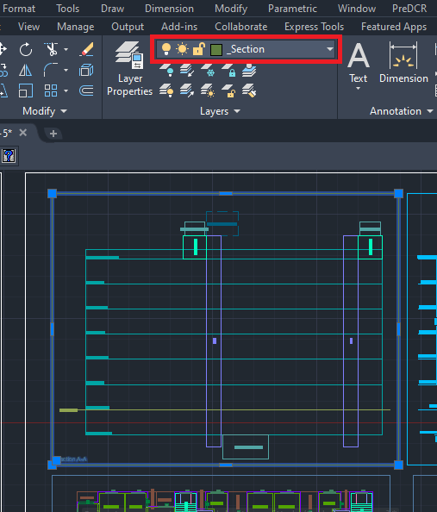

4.5.6. How to draw print additional details items in ‘_PrintadditionalItem’ layer?
- Go to layers drop down Select ‘_PrintadditionalItem’ layer.
- Draw all architectural details (like Septic tank details, RWH Details, Compound Wall Details) on ‘_PrintAddtionalDetail’ layer.

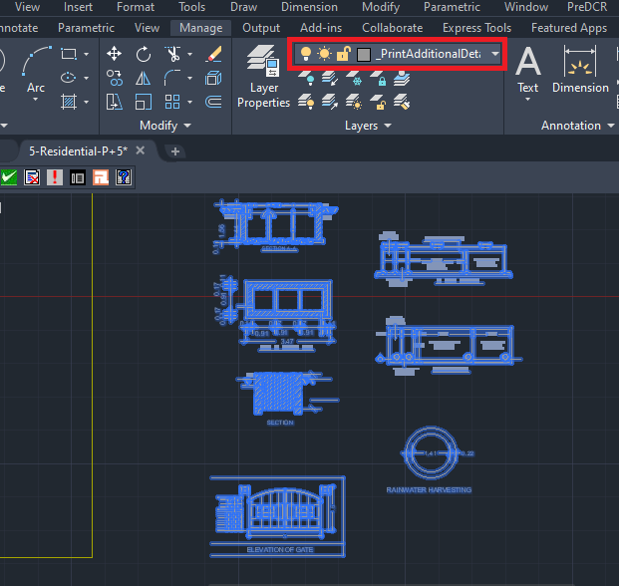

4.5.7. How to draw elevation on ‘_Elevation’ layer?

- Go to layers drop down Select ‘_Elevation’ layer.
- Draw every side elevation on ‘_Elevation’ layer OR you can can change elevation layer architecural layer to PreDCR ‘_Elevation’ layer.

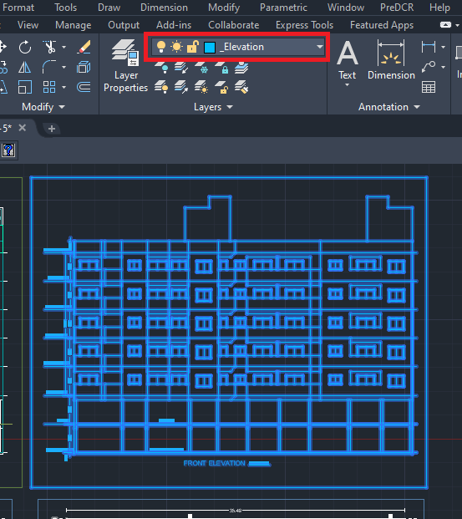

4.5.8. How to draw floor plans, section, elevation and print additional details inside the ‘_Building’ layer?
- Go to layers drop down Select ‘_Building’ layer.
- Draw ‘_Building’ layer poly to group all floor plans, section, elevation and print additional details of the same Building.

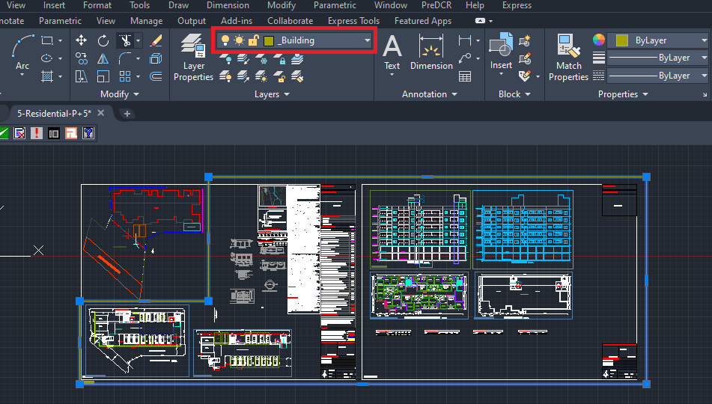
4.5.9. How to link the building plan to PWork ?
- To link building plan to Pwork .
Go to PreDCR menu-Select ‘Assign name’ Building and Propwork.
Select ‘Building poly’ in drawing.
Fill up the ‘Building and Propwork Name’ dialog box:
Fill up ‘Wing Name’ and ‘Building Name’
Select Propwork in the drawing.
It will link the building plan to Pwork .

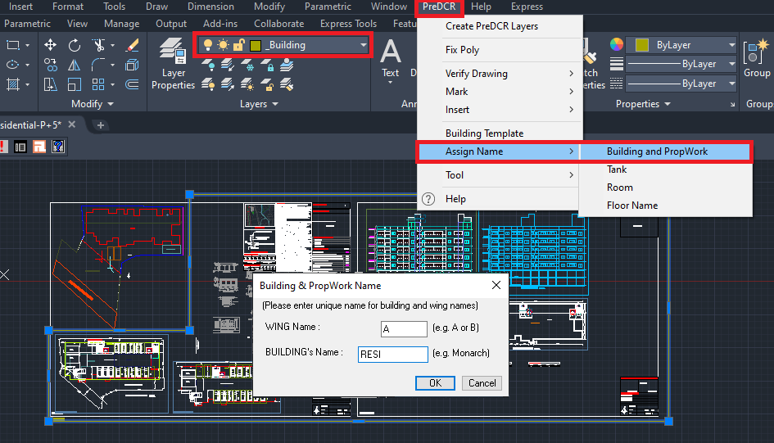
After completing the conversion proceed to the next tab of the PreDCr toolbar:

- How to Fix Poly?
This command is used once the complete drawing conversion is done. This tab will check all the polylines on the PreDCR layer and remove extra vertices found on polyline or duplicate entity. This command should be used (before verifying the drawing) every time you add any new entity in the drawing.
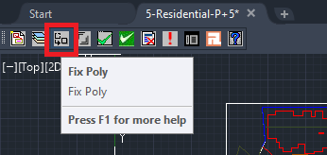

- How to Mark Margin?
- To Mark Margin:
Click on the third tab of the toolbar ‘Mark Margin’ tab.
Marhin dialog box:
Select ‘Front’/’Side1’/’Side2’ and ‘Rear’ side in the drawing.
Once done select Ok.
Select the plot and give ‘Plot width’ and ‘Plot depth.

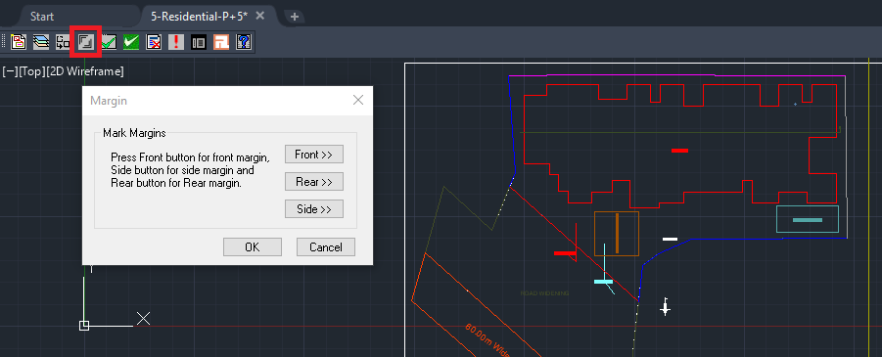

- How to Verify close Poly?
This command will verify the current drawing as required by AutoDCR. It will verify that
LWPOLYLINE entities on the selected layers are closed and contain one text.
Shows ‘Select layer box’ select ‘Ok’.

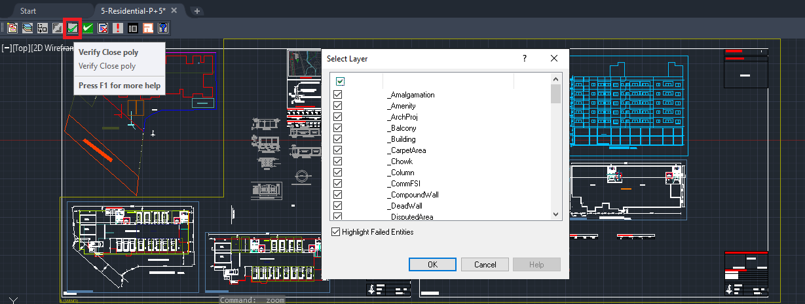
- How to Verify the Current Drawing?
This command is used to verify the layout and building-level objects in the current drawing plan.
Major checks are as follows:
- Check if these entities are drawn as closed LWPOLYLINE.
- Name text is given to all objects.
- Entities are placed exactly inside their parent objects (container).
- Naming conventions are followed properly.
In the "Verify All Drawing Dialog" you can select the layout or building objects to be checked. To view the result, press the OK button.
Select ‘OK’ in Entity not found list dialog box.
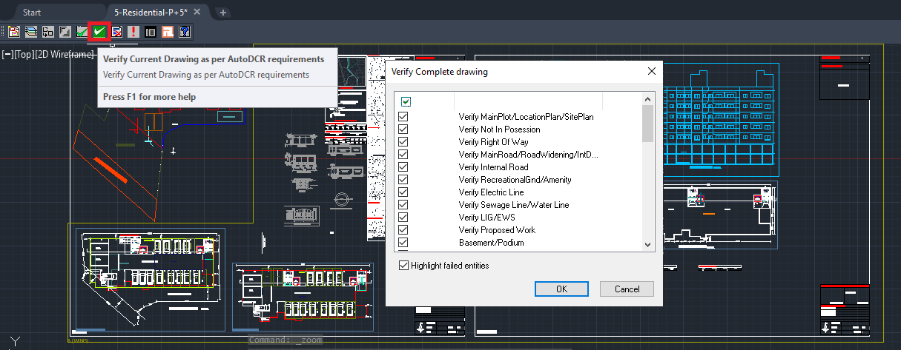
PreDCR will start checking all corresponding objects in the currently open drawing and then display the status as OK or a list of failed objects with the reason of failing in the dialog as shown.

- How to view the ‘PreDCR Report’?
In the Plot details dialog box select in case of any deduction for road widening area, reservation area, or existing road area. Verify plot use and plot sub use.

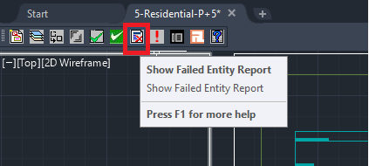
If all the details are found correct please select ‘OK’.
In the Building, details table verify all the buildings by selecting each one of them.
Select Ok.
In Floor details table verify all the floors by selecting each one of them.
Select Ok.
This command will generate the PreDCR Report having all the Project details. All the verified and failing entities having Information will be shown in this Report.

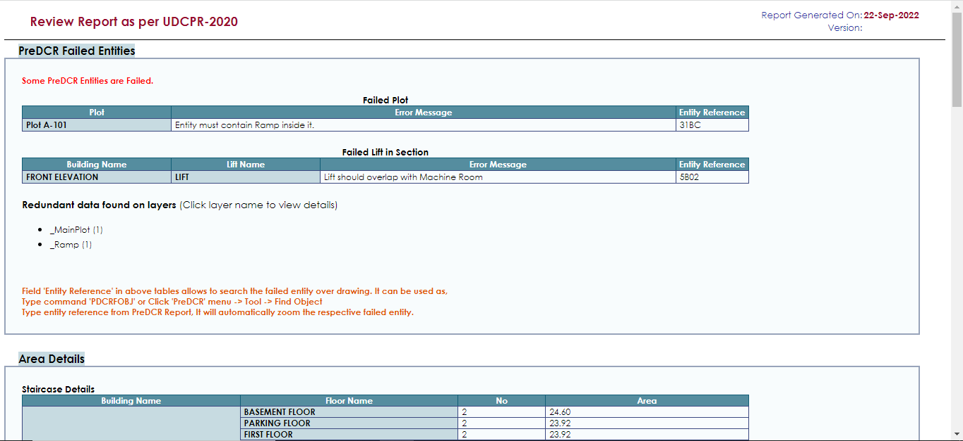

- How to use ‘Show Objection List’ tab?
This command gives the list of all minimum required entities which are not there in your drawing. If all required entities found then it gives a message that minimum required entities are present in drawing.
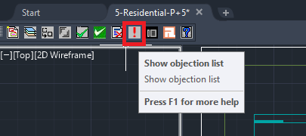

- How to map architectural layers with PreDCR MH layers?
- Click on ‘Layer mapping for current drawing’ tab
- This is to map the architectural layers with PreDCR layers.
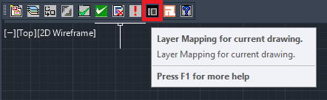
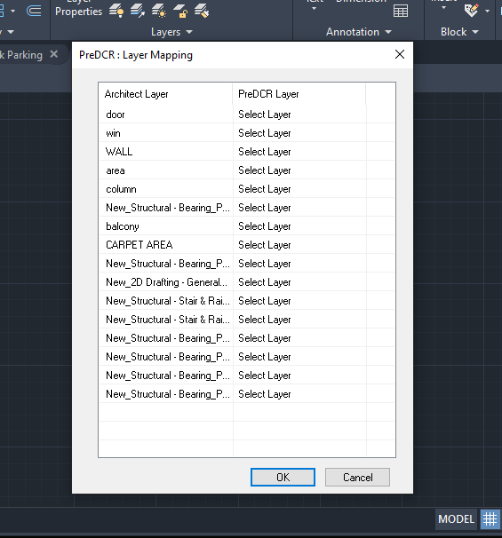

- How to view active help?
- Click on ‘Active Help’ tab for quick help regarding PreDCR layers.
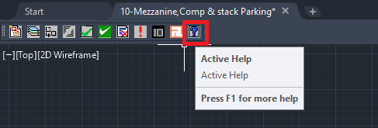

This the last page of the document.
Thank You.

